

AHU CONTROLLER TEST DATA SHEET

|  |  |  |
| --- | --- | --- |
| P/N: 413-8005-1-47 |  | Date: 05/02/2019 |
| DRIVER S/N: 602 |  | Time: 12:34 |
| UA: 47 |  | Tested by: ELI |
| Hardware Rev: BLDC_60A_V6 |  | Approved by: ELI |
| Software Rev: 5.3.8d |  |  |
| Parameters rev.: AHU-LEFT version 0.2 |  |  |
| Tester Software Version: V1.2r |  |  |
| DSP BOARD S/N: 1842003 |  |  |
| POWER BOARD S/N: 1841003 |  |  |
|  |  |  |
|  |  |  |
|  |  |  |
|  |  |  |
|  |  |  |
|  | Equipments Used |  |
|  |  |  |
| Equipments | Model No | Serial No |
| Power Supply |  |  |
| Digital Multimeter |  |  |
| CAN Interface |  |  |
| BLDC Tester |  |  |
| PC |  |  |
| Heater |  |  |
| RS-232 Interface |  |  |
| Current Meter |  |  |

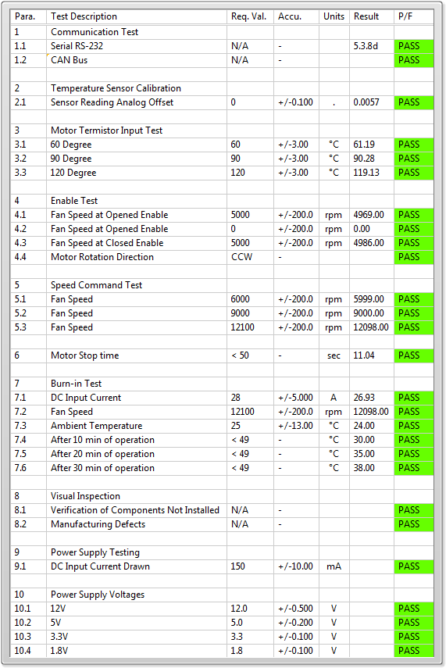

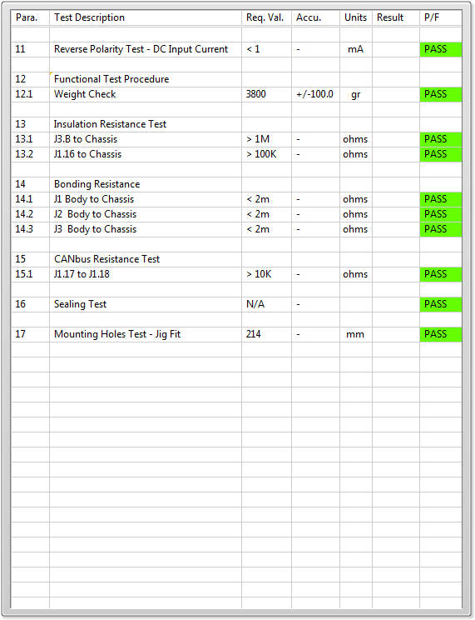

General result:

Test-Operator:____ ELI_________ Q.A.:__________________________